|  |
| --- |
| *Technical Design Specification* |

|  |  |  |  |
| --- | --- | --- | --- |
|  | Name | Role | Date |
| Author | Raju Lakide | ABAP Technical Consultant | 29-04-2025 |
| Reviewer |  |  |  |

Contents

Index of Changes 3

1. Purpose and objective 4

2. Type of Specification 4

3. Document References 4

4. Technical Design 4

4.1. Technical Design Summary 4

4.2. Data Dictionary 4

4.3. Transaction 4

4.4. Classes 5

4.5. BadI 5

4.6. Other Kind of development 6

4.7. Error Condition Handling 6

4.8. Additional Information 6

Index of Changes

|  |  |  |  |
| --- | --- | --- | --- |
| Date | Version | Description of Change | Author |
| 29-APR-2025 | 2.0 | Based on the requirement implement the lumpsum billing in SD process | Raju L |
|  |  |  |  |
|  |  |  |  |

# Purpose and objective

# This document describes the technial specification for the correction for code land data

# Type of Specification

|  |  |
| --- | --- |
| Program type: | Report (read only)  Update function    Utility  Enhancement (user-exit, BADI, function module)  Modification  SAP GUI Dynpro  Web Dynpro  Interface  Inbound  Outbound  BW extractor |

# Document References

|  |  |  |  |
| --- | --- | --- | --- |
| Ref. | Document Name | Version | Remarks |
|  |  |  |  |

# Technical Design

Technical Design Summary

**Decommission event.**

Business needs to implement the lumpsum billing in SD process

**Updated Logic:**

Step1: While creating the SO using transactions ZWB01 & ZWB02 select the transporter as Lumpsum on save the SO will be generate

**Note**: If the customer is lumpsum customer

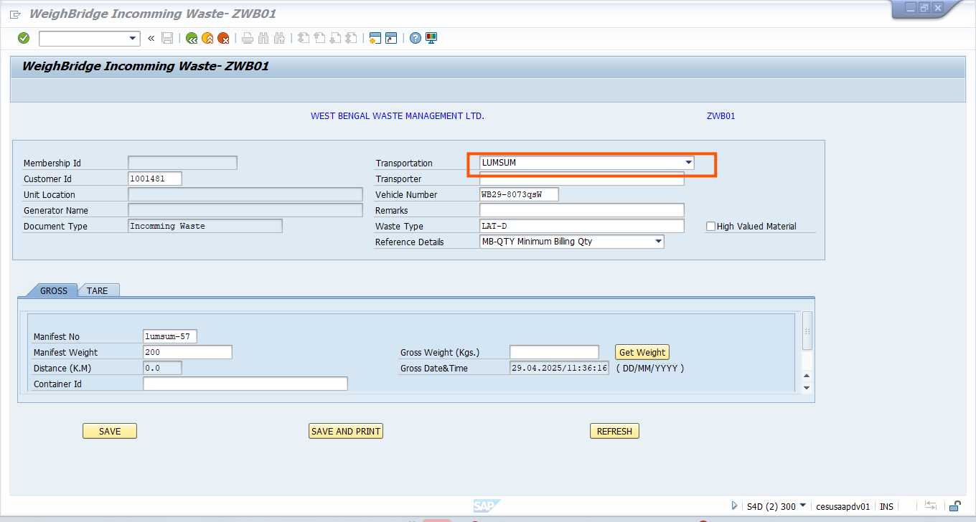

If the Customer is not active in zv12 then error will be trigger

In ZMSO select the transporter as Lumpsum

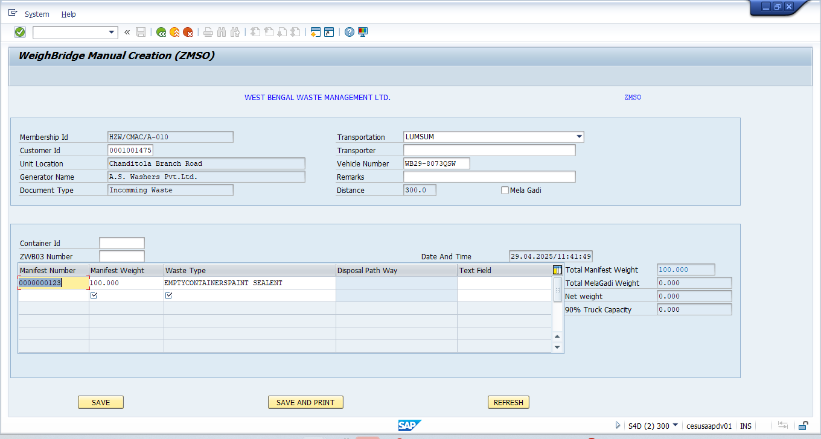

Click on save the SO will be generate

If we are creating the transporter as lumpsum only single line item will be update in so(like as generator)

Data Dictionary

n/a

Transaction

**ZV12**

**ZWB01**

**ZWB02**

**ZMSO**

Classes

n/a

BadI

n/a

Other Kind of development

n/a

Error Condition Handling

n/a

Additional Information

n/a